**Task 1: Deploy a Scalable WordPress Website Using EC2, RDS, ALB, and ASG (Dynamic Site)**

[GitHub Repo](https://github.com/Tahawyy/JSYC-Project/tree/main) | [CFN ALB](http://wordpres-alb-ye65wc2rkdxd-2096908685.us-east-1.elb.amazonaws.com/) | [NO CFN ALB](http://wordpress-alb-899778082.us-east-1.elb.amazonaws.com/)

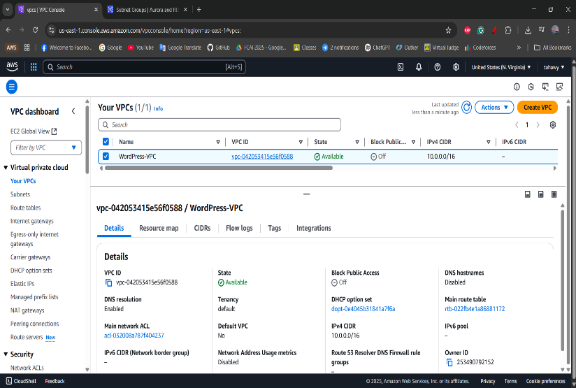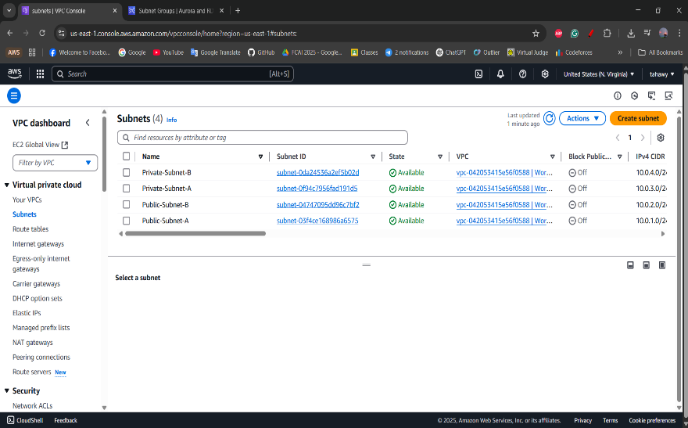VPC and Subnets:  
  
Creating a VPC to have our own private network inside the cloud for our WordPress website and four subnets (two public and two private) by placing subnets in **two different AZs** to ensure that if one AZ experiences and outage, the application remains available in the other AZ.

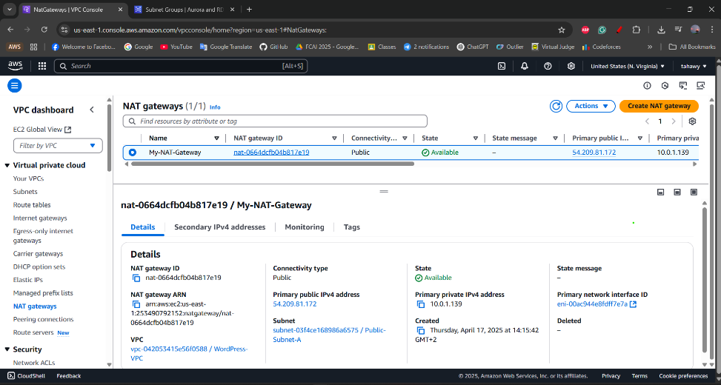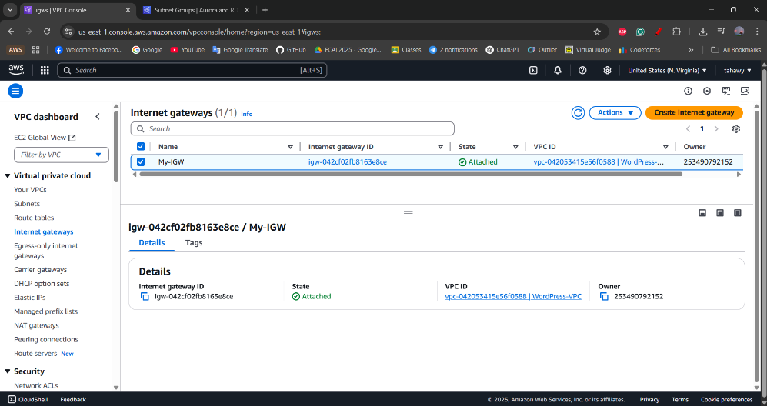  
  
IGW and NGW:  
The IGW is to allow resources in a **public subnet** to communicate directly with the internet. The NGW is to allow resources in **private subnets** to initiate outbound traffic without exposing them to inbound internet traffic.

Route Tables:  
  
Route Tables are used to control the routing of network traffic within VPC. They determine how packets are directed between subnets, the internet, and other network resources.  
Added a route to direct traffic destined for the internet (0.0.0.0/0) to the Internet Gateway (IGW). This allows resources in the public subnet to access the internet. Also, there was added a route for internet-bound traffic (0.0.0.0/0) to the NAT Gateway. This allows instances in private subnets to access the internet for updates and patches, but they remain inaccessible from the internet.

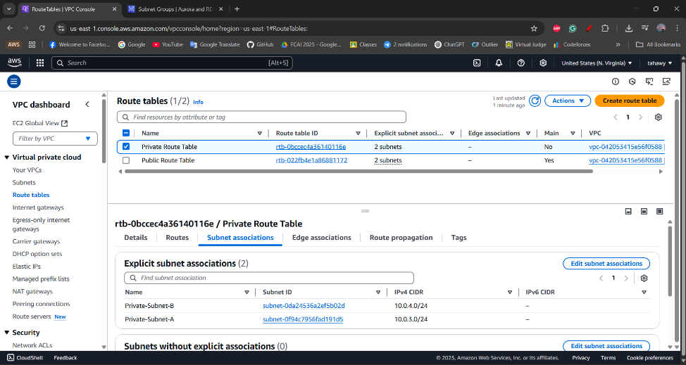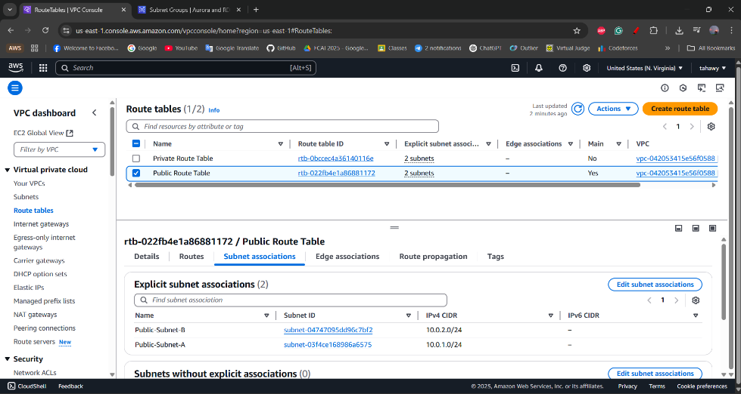

RDS Subnet Group:

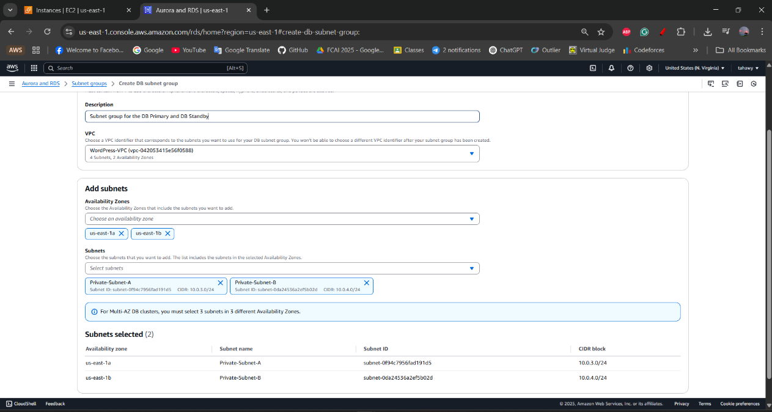This is a subnet group for RDS that has two private subnets, they are two for high availability and security, and when setting up **Amazon RDS** for WordPress project, AWS requires you to create a **DB Subnet Group** with **at least two private subnets in different Availability Zones (AZs)**.

Instances:  
  
The instances created that the WordPress Site has deployed in them either manually or using CloudFormation.

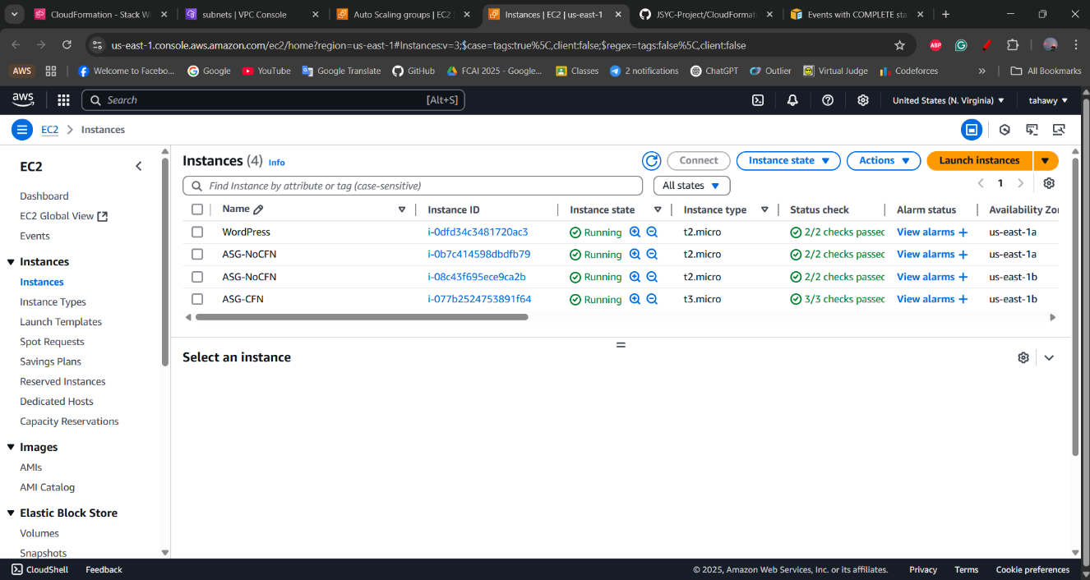

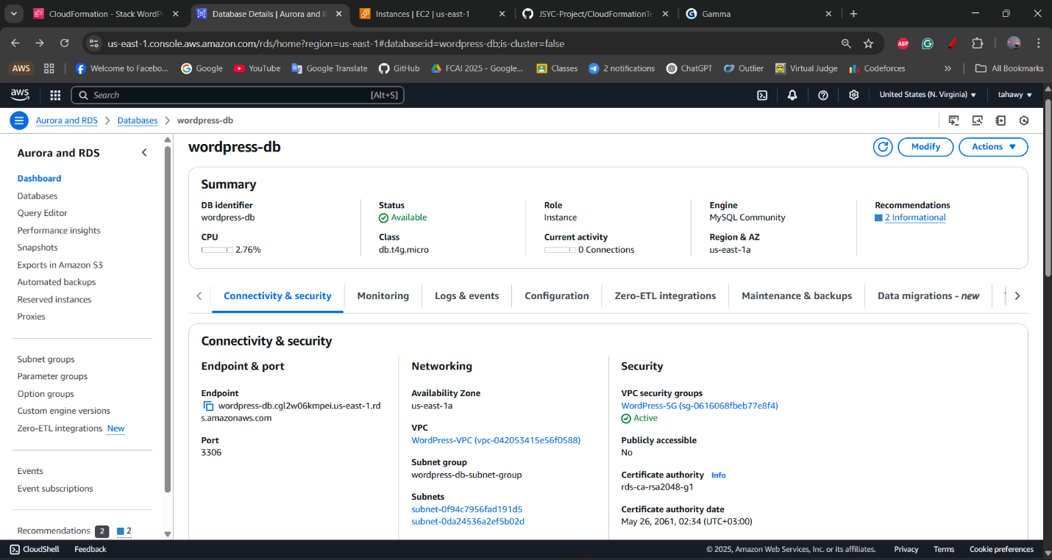RDS:   
  
This is the database that was created for WordPress because it is a dynamic content management system that stores and retrieves content from a database. Without a database, WordPress cannot manage content or maintain user data, making it non-functional. It’s connected to the two private subnets.

Installation of WordPress in Instance Manually:

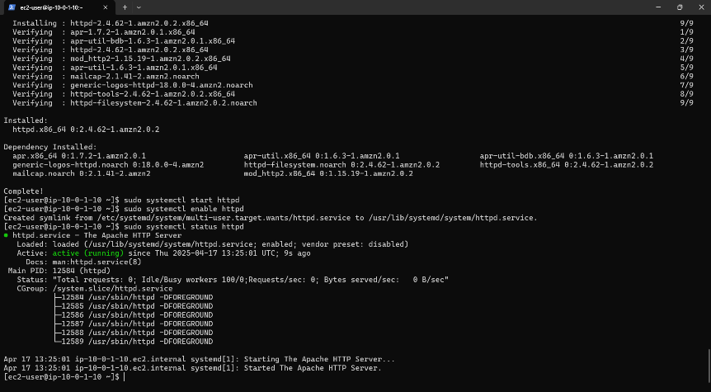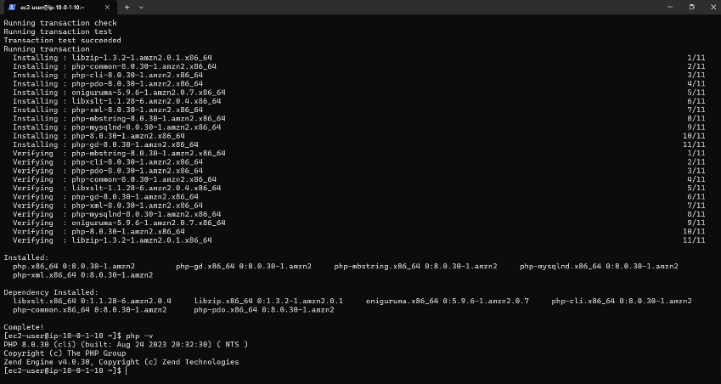Those are screenshots of installing Apache and PHP which are required first to install WordPress later. Also, the installation of the DB which is required for WordPress.

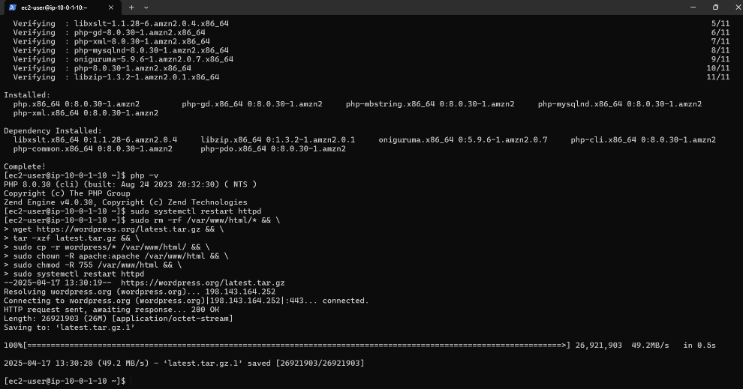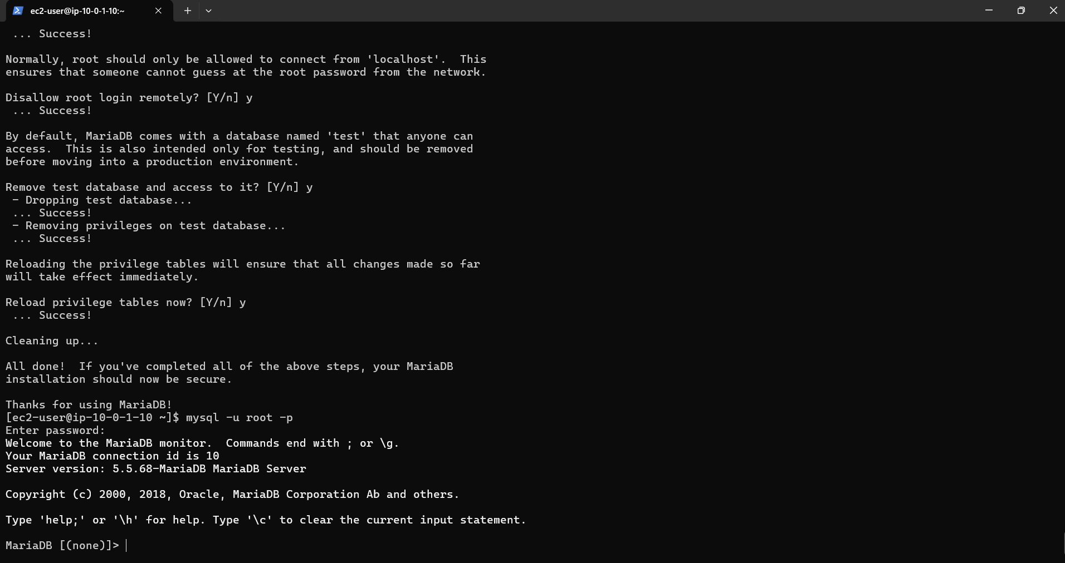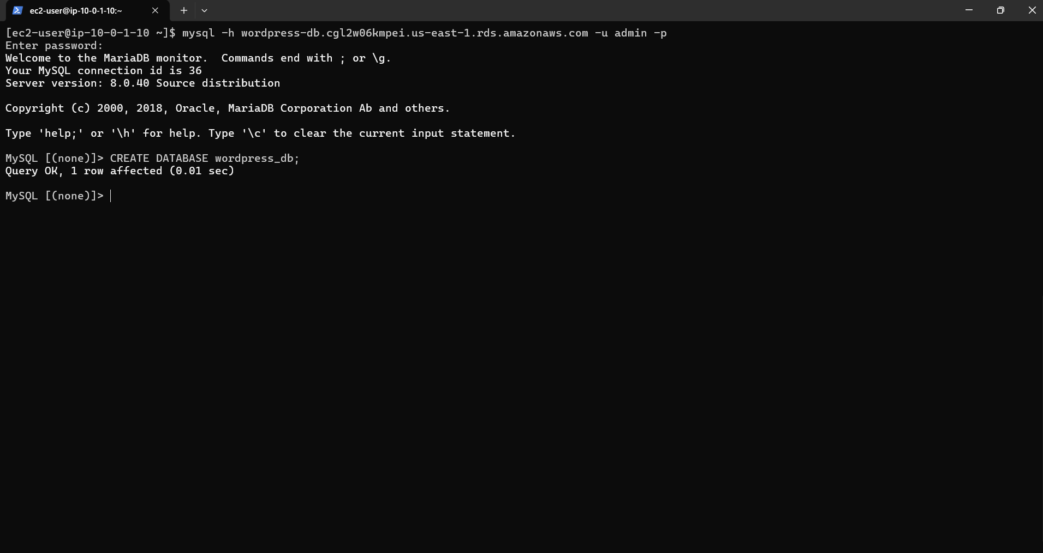

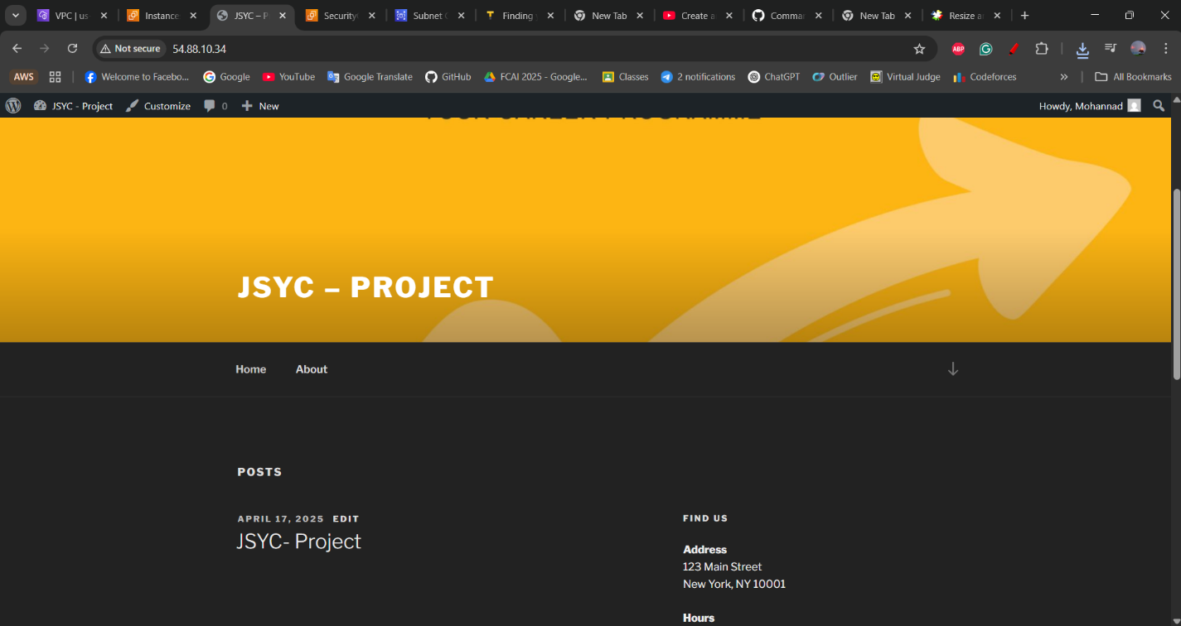Installation of WordPress from Website:  
  
  
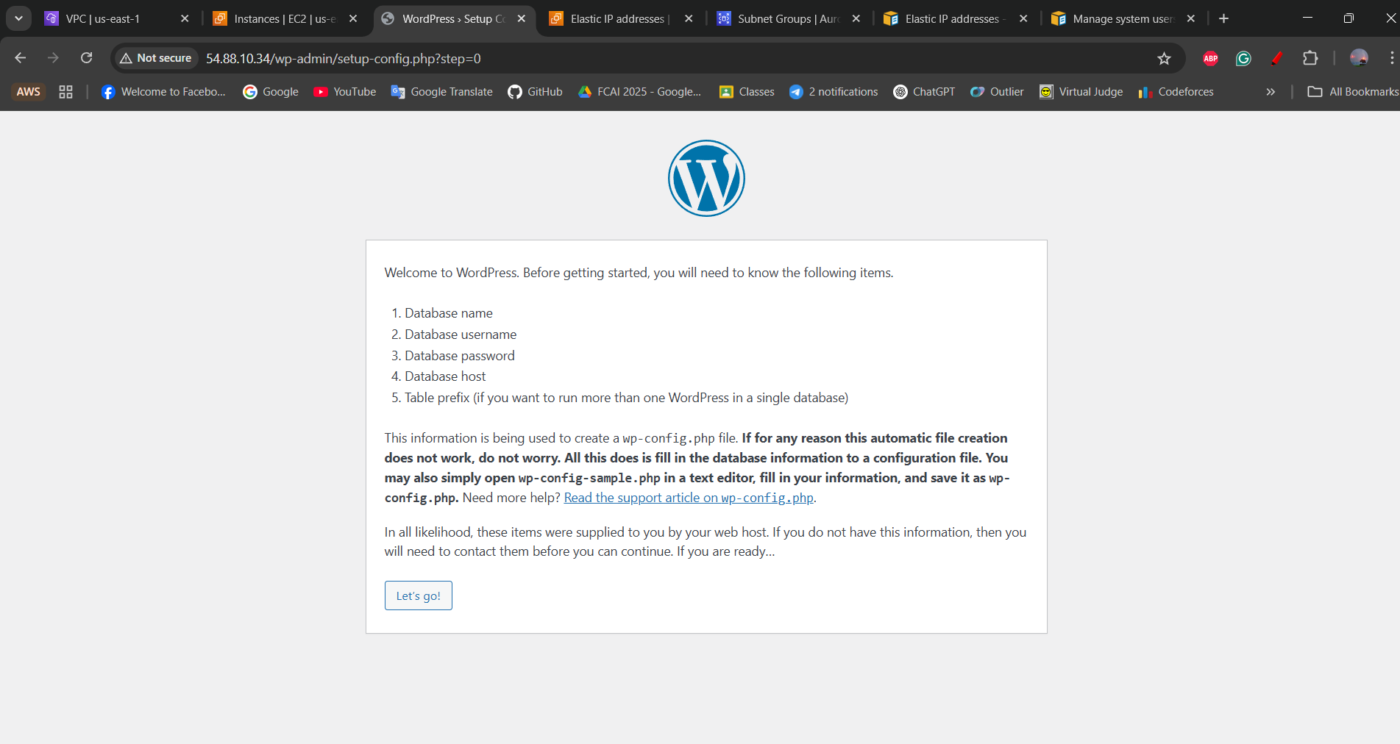  
  
  
  
ALB & ASG:   
  
ALB helps in distributing incoming traffic across multiple EC2 instances, Ensuring high availability and fault tolerance. While ASG automatically adds or removes EC2 instances based on demand, Ensuring the right number of instances are always running.  
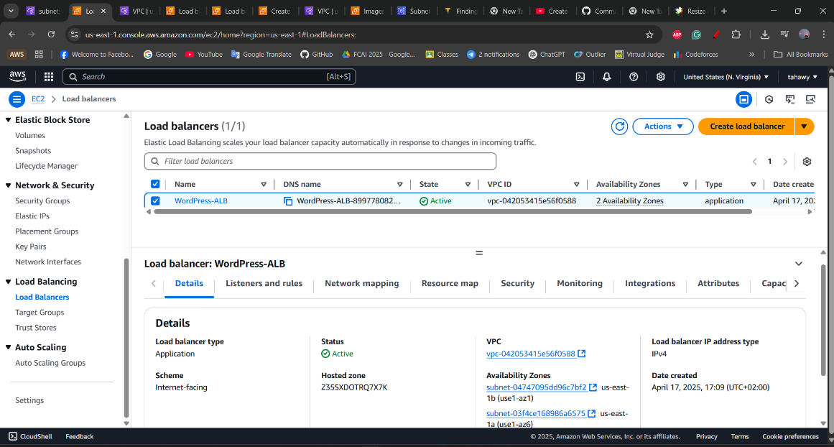  
  
  
  
  
  
  
  
  
  
  
  
  
  
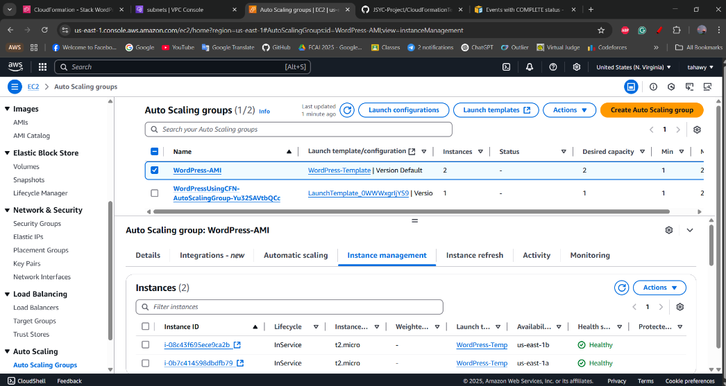  
  
  
  
  
  
  
  
  
  
  
  
  
  
  
  
  
  
  
  
Accessing Website from ALB DNS  
  
  
  
  
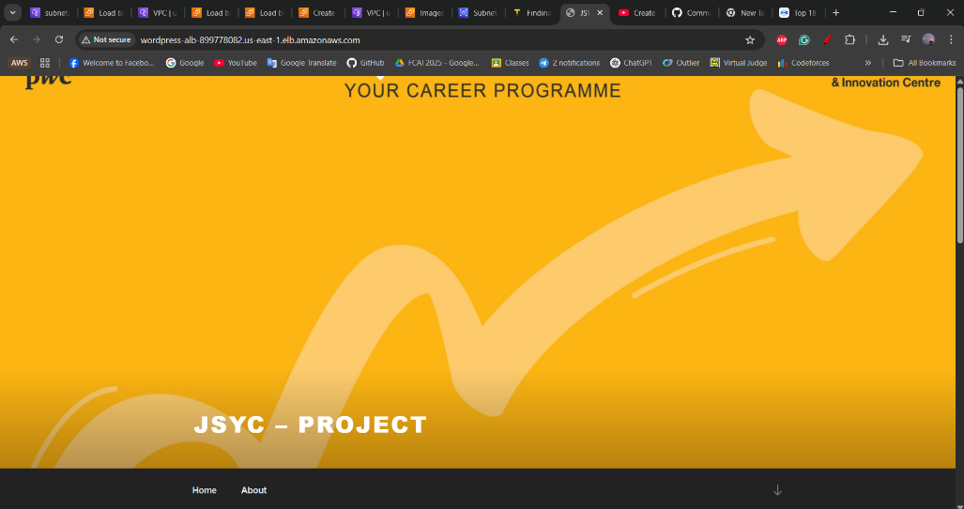  
This is a Target Group screenshot, Target Group routes traffic from the ALB to registered EC2 instances or other targets.  
  
  
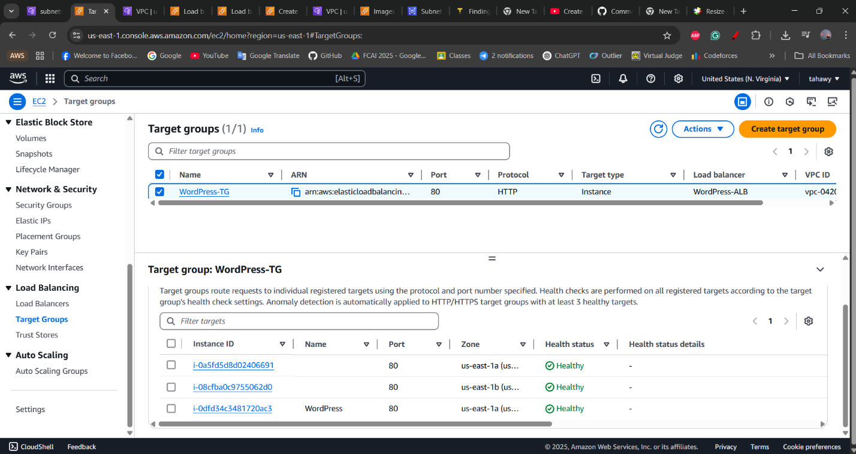S3 Bucket:   
  
Helpful in Storing static website content like HTML, CSS, JavaScript, and media files. But here I saved all the   
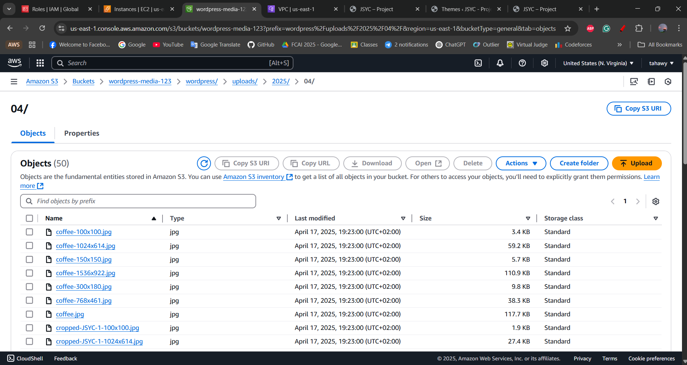website photos.  
  
CloudFormation:

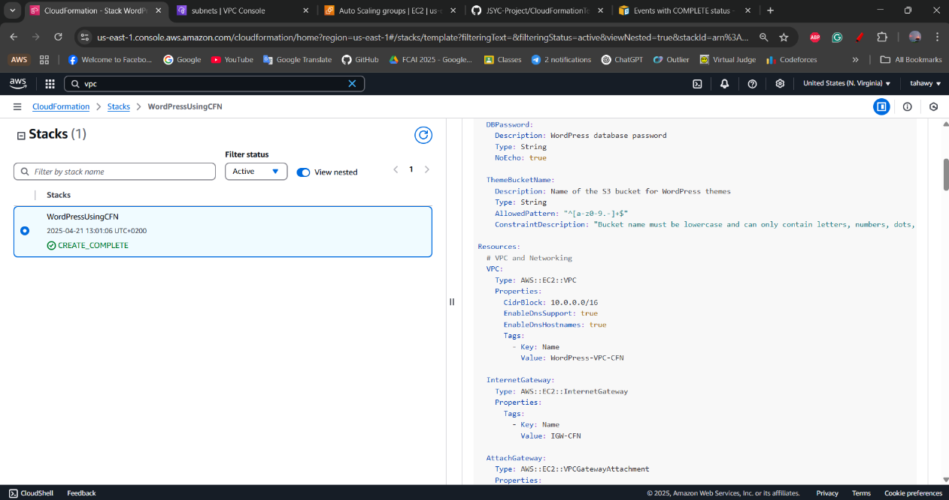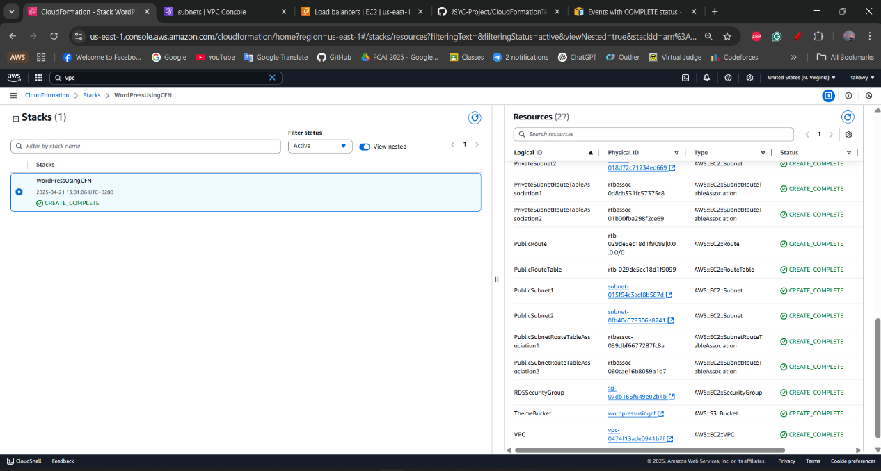I switched to using CloudFormation after realizing that creating and deleting AWS resources manually was time-consuming and error prone. With CloudFormation, I can define all my infrastructure in a single template, which automates the entire process whether it's launching or tearing down a complete stack. This not only saves a lot of time but also ensures consistency and reduces the chances of missing any resources.

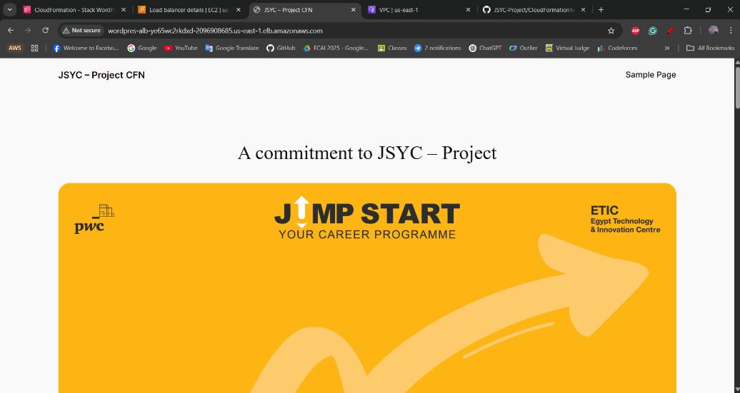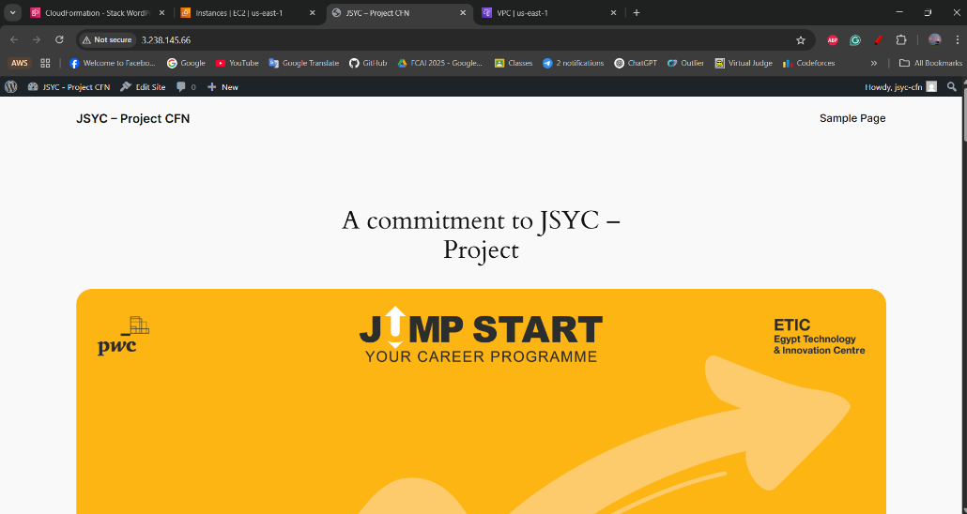

Using CFN Instance IP Address:

Using CFN ALB DNS: